**CP Club 365 Days Challenge**

**Programming language – PYTHON**

**Problem Statement**

<https://www.codechef.com/problems/REMOVEBAD>

Git :- <https://github.com/Vedantbharad2603/CP_club_365_Days>

**Your Code**:

# 0x100Day of 0x365Days challenge

# VEDANT BHARAD

# 25-1-2023

t=int(input())

for loop1 in range(t):

    n=int(input())

    arr=list(map(int,input().split()))

    arr2={}

    for loop1 in arr:

        if loop1 in arr2:

            arr2[loop1]+=1

        else:

            arr2[loop1]=1

    print(n-max(arr2.values()))

**Output (Screen Shot)**:

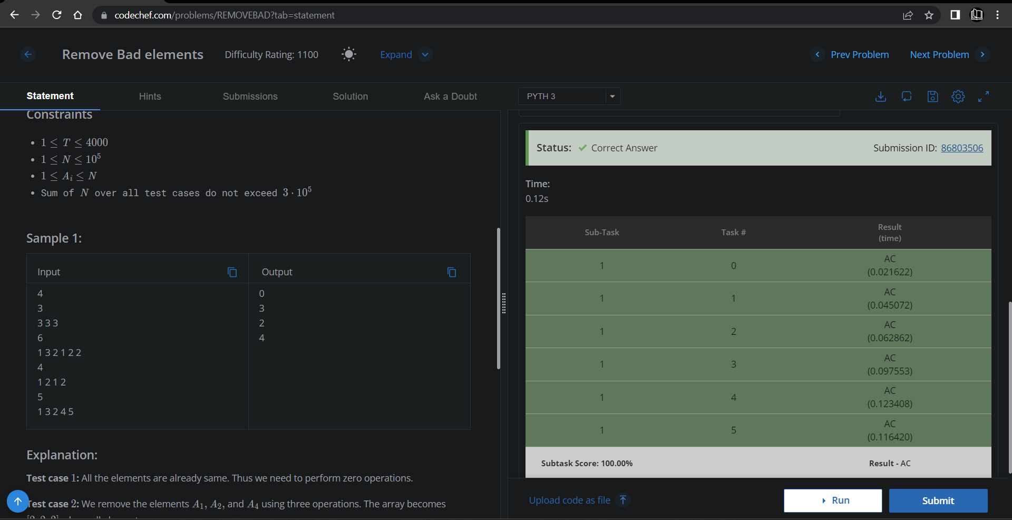

**Understanding about problem:**

In this task first I need to find number which have highest frequency and then divide that frequency from length of arr.

Note: If you can't understand the problem, feel free to contact us and we'll help you. Please don't copy and paste from anywhere.

ALL THE BEST

Team CP Club